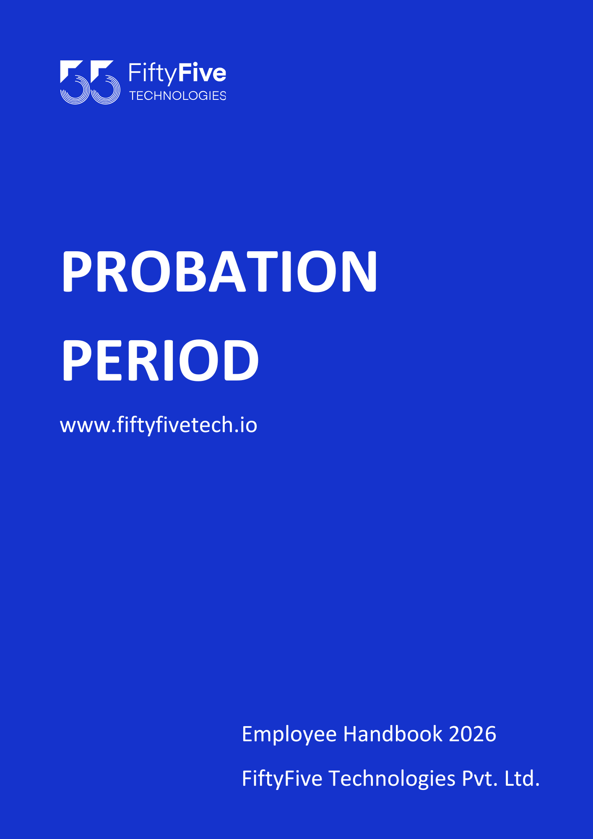

PROBATION PERIOD
Document Release Notice
This FiftyFive Technologies Policy on probation period is released for use in FiftyFive Technologies Pvt Limited with effect from 01 January 2026.
This document is subject to FiftyFive Technologies Pvt Limited Procedure and subject to change any time as per the company policy.
Approved By: Jyothi Sharma (CEO-FiftyFive Technologies Pvt. Limited)
Approved By: Sanchi Saxena (Head HR FiftyFive Technologies Pvt Limited)

PROBATION PERIOD

Introduction
FiftyFive Technologies Pvt Limited has a mandatory Probation Period that every experienced professional who joins the company needs to undergo. The Probation Period enables the employee to understand his or her role, goals, Intern / New Joinee, and responsibilities and deliver them as per FiftyFive Technologies' expected performance standards. At the end of the successful Probation Period, the employee is confirmed as a permanent employee.
Confirmation for an experienced employee is an event that marks the end of the probation period wherein the experienced professional is confirmed as a permanent employee.

Purpose
The purpose of this policy is to introduce the employee to the work culture, environment and performance expectations at FiftyFive Technologies, and ensure that he or she is aligned with the organization's objectives from the beginning of his or her career in FiftyFive.

Applicability
This policy is applicable to all new joiners of FiftyFive Technologies, including Experienced Professionals.
This policy is not applicable to Freelancers, Part-time employees, or Interns who are currently undergoing their Training Period.

Definitions
Term | Definition
Experienced Professional (EP) | An Experienced Professional is a new member who joins FiftyFive Technologies as a full-time employee and possesses a minimum of six (6) months of prior relevant work experience at the time of joining the Company.
Probation Period | The probation period is a mandatory period which every experienced professional who joins FiftyFive Technologies Pvt Limited should undergo before he or she is confirmed as a permanent employee.
Confirmation | Confirmation for an experienced employee is an event that marks the end of the probation period wherein the experienced professional is confirmed as a permanent employee.

Provisions
- The Probation Period for all new joiners who are Experienced Professionals is three (3) months.
- The key focus during the Probation Period is to induct the employee into the organization and to review their performance, behavior, and suitability for permanent employment.
- During the Probation Period, the Company will closely monitor the employee’s performance, work attitude, and availability. Failure to meet the expected standards may result in the Company taking appropriate action regarding employment.
- Policy violations, misconduct, or serious performance issues may result in immediate termination regardless of review timelines.
- Employees on probation may not be eligible for certain benefits, such as privilege and additional leave entitlement, or long-term perks, until confirmation.

Induction During Probation
- An effective induction program is critical for recruitment, employee engagement, and retention.
- For all new joiners, induction is conducted at the organization level. FiftyFive Technologies conducts a 4-day induction program for all employees immediately after joining to familiarize them with the Company’s vision, values, processes, policies, and culture.

Performance Monitoring & Review
- Employee performance, work quality, attendance, and behavior will be closely monitored during probation.
- Periodic performance reviews will be conducted:
- For Experienced Professionals: at the end of 3 months.
- The Company may extend the probation period if performance is not fully satisfactory.
Reviews will assess:
- Task completion and quality of work
- Teamwork, communication, and collaboration
- Adherence to Company policies and culture

Integration with Performance Management System (PMS) & PIP
- Employees on probation are subject to the Performance Management System (PMS) of the Company.
- Performance will be monitored continuously, and feedback will be provided periodically.
- If performance gaps or areas of improvement are identified, the employee may be placed under a Performance Improvement Plan (PIP) even during the probation period.
- PIP provisions, including review period, goals, and outcomes, will apply as per the Performance Management System policy.

Leave and Benefits During Probation
- Employees on probation are not eligible for certain benefits and long-term perks, including some privilege and some categories of additional leave entitlements mentioned in the leave policy of FiftyFive technologies.
- Specifically, leave balances such as Casual Leave, Privilege Leave, or Additional Leaves will not accrue or be available until the employee is confirmed.
- In case of emergency, employees may avail Loss of Pay (LOP) leave with prior approval from the Reporting Manager and HR.
- Any LOP availed during probation cannot be adjusted or converted to other leave types after confirmation.

Notice Period During Probation
- Either the Company or the employee may terminate employment during probation with two months’ notice or payment in lieu, unless otherwise specified in the offer letter and notice period policy of FiftyFive Technologies,
- The Company reserves the right to terminate employment immediately in cases of misconduct, serious policy violation, or gross negligence.

Extension of Probation
- The probation period may be extended if the employee’s performance, behaviour, or suitability for the role is not fully satisfactory.
- Any extension will be communicated in writing with a clear duration and performance expectations.
- Maximum probation extension shall not exceed 3 additional months, unless specifically approved by the HR Head and business leadership.

Confidentiality and Conduct
- All evaluations, feedback, and records related to the probation period are strictly confidential.
- Employees must not disclose or discuss probation-related feedback, evaluations, or performance gaps with colleagues.
- Breach of confidentiality may lead to disciplinary action, including but not limited to withholding confirmation, corrective measures, or termination.

Reference to Other Policies
All Company policies, including Code of Ethics and Business Conduct, Assets, Attendance, Leave, PMS and Separation Policy, POSH, Referral, Holiday, are applicable during the probation period unless explicitly stated otherwise.

Termination During Probation
- The Company reserves the right to terminate employment at any time during probation due to unsatisfactory performance, behavior, or policy violations.
- Termination may be immediate or require short notice, as determined by the Company.
- Employees leaving voluntarily during probation must follow applicable exit formalities as per the separation policy of FiftyFive Technologies.

Confirmation of Employment
- Confirmation is subject to satisfactory performance, conduct, and compliance with Company policies.
- Confirmed employees will be permanent members of the organization.

Right to Amend Policies
This Employee Handbook is intended to provide general guidance on Company policies and practices. FiftyFive Technologies reserves the right to amend, modify, suspend, or withdraw any policy, procedure, or benefit described in this handbook at any time, with or without notice, based on business, operational, or legal requirements.



